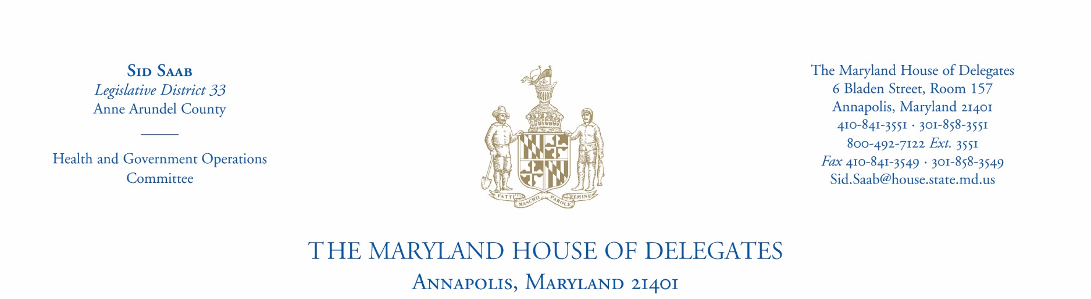
Dear Scholarship Applicant:

Thank you for your interest in applying for a House of Delegates Scholarship for the 2020-2021 academic year.

The Maryland Higher Education Commission (MHEC) has established certain minimum criteria for the House of Delegates Scholarship Program. To be eligible for a Delegate Scholarship you must attend a Maryland college, university, or private vocational school. If you attend an out-of- state school and your academic program/major is not offered in Maryland, you can still be eligible for a Delegate Scholarship. However, you must first receive unique major approval from MHEC.

All applicants must set up an account with MHEC. This process can be completed at www.mhec.state.md.us.

Your scholarship application will be reviewed based on the following criteria:

- Your education goals/reason for attending college.
- Qualities that make you stand out as a candidate. These can include employment (hours worked per week), academic, school groups, hobbies, or community-related activities and/or certain achievements.
- Completion of requested essay.
- Grade point average and/or improvement of such.
- Must live in District 33.

Please complete the enclosed application form (2-pages) and return along with one copy of your most recent academic transcript (official or unofficial). The deadline for submitting your application and transcript is April 13, 2020. Applicants will be notified of the outcome as soon as review is complete, usually in May. Awards will be directly distributed by MHEC to the school in the fall and allotted by semester. This scholarship is not automatically renewed, but must be applied for each year.

If you have any questions or comments, please contact my office. Chris Ronk, Administrative Assistant, will be able to assist you. I wish you much success in your academic endeavors and aspirations.

Sincerely,
Sid Saab
Delegate, District 33

Delegate Sid Saab, District 33
2020-2021 House of Delegates Scholarship Application
6 Bladen Street, Room 157, Annapolis, Maryland 21401-1991
Office: (410) 841-3551 - Email: Sid.Saab@house.state.md.us

Please provide a copy of your most recent transcripts (unofficial transcripts are acceptable). Your complete application (2 pages) must be post marked by April 13, 2020 to receive consideration.
PERSONAL INFORMATION
NAME OF APPLICANT (LAST, FIRST, M.I.) |  |  |  | DATE OF BIRTH | SOCIAL SECURITY NUMBER  (needed for tax purposes) |  | SEX  M F
HOME ADDRESS |  |  |  | CITY |  |  | ZIP CODE
E MAIL ADDRESS |  |  |  |  | HOME PHONE |  | MOBILE PHONE
FATHER / GUARDIAN NAME |  |  |  |  | OCCUPATION
MOTHER / GUARDIAN NAME |  |  |  |  | OCCUPATION
ACADEMIC INFORMATION
NAME OF CURRENT SCHOOL |  |  |  | SCHOOL LOCATION (CITY, STATE) |  |  | CURRENT G.P.A.
NAME OF COLLEGE / UNIVERSITY/VOCATIONAL INSTITUTION ATTENDING FALL  2020 |  |  |  | COLLEGE / UNIVERSITY/VOCATIONAL INSTITUTION LOCATION (CITY, STATE)
ENROLLMENT STATUS (Fall 2020)  FULL-TIME PART-TIME |  | GRADE LEVEL (Fall 2020) |  | STUDENT STATUS (Fall 2020)  VOCATIONAL UNDER GRADUATE GRADUATE
EDUCATIONAL GOAL / REASON FOR SCHOLARSHIP (STATE SPECIAL CIRCUMSTANCES TO BE CONSIDERED)

EXTRA-CURRICULAR ACTIVITIES AND COMMUNITY SERVICE (ATTACH RESUME IF APPLICABLE)
EMPLOYMENT HISTORY - Additional Space on Reverse
EMPLOYER |  |  | POSITION (hours worked per week) |  |  | START DATE |  | END DATE
Delegate Sid Saab, District 33
2019–2020 House of Delegates Scholarship Application
6 Bladen Street, Room 157, Annapolis, Maryland 21401-1991
Office: (410) 841-3551 - Email: Sid.Saab@house.state.md.us

Part II – Applicant’s Essay

Essay Requirement:

Please write a 300 word essay giving your opinion on the pros and cons of the rise of social media.

You must provide a copy of your most recent transcript (unofficial transcripts are acceptable). Your application must be postmarked by April 13, 2020 to receive consideration.

_____________________________________________ ________________________________
APPLICANT SIGNATURE DATE
Please sign and complete this application. I acknowledge that I am a United States citizen and a legal resident of Maryland District 33, and that all provided information is complete and accurate. |  | Mail To:  Delegate Sid Saab  6 Bladen Street, Room 157  Annapolis, Maryland 21401-1991

