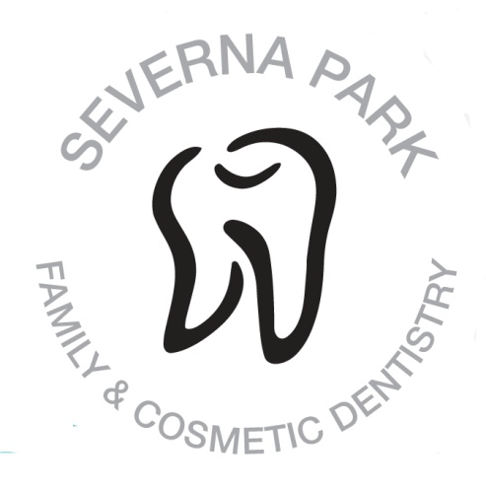
Healthcare Scholarship offered by
Severna Park Family & Cosmetic Dentistry
Russell, Deasey, Wright & Zitofsky DDS
22 Truck House Rd. Suite 3
Severna Park, MD 21146
www.thetoothplace.com
410-647-4269

The $500 scholarship will be awarded to a student at Severna Park High School who is planning on attending college for a degree in the health care field. The student must have a cumulative GPA of 3.0 or better and this will be verified by the student’s guidance counselor.
Each applicant must complete this page and attach separately a one page essay on the health care area they have chosen as a major, why they have chosen this area and what they hope to accomplish with this degree. DO NOT put any personally identifying information in or on your essay so these may be judged anonymously. DEADLINE April 20th, 2020.
Please deliver directly to our office or to the guidance office.

Print Name:______________________________________________________
Home Phone:____________________________________________________
GPA:____________________________________________________________
College Area of Study:______________________________________________

Signature:________________________________________________________
*** Essays with identifying information will be disqualified. Please make and keep a copy of the application and essay for your records.

